UNDERSTANDING THE COST OF NOT COMPLYING WITH THE ADAM WASH ACT’S SORNA PROVISIONS

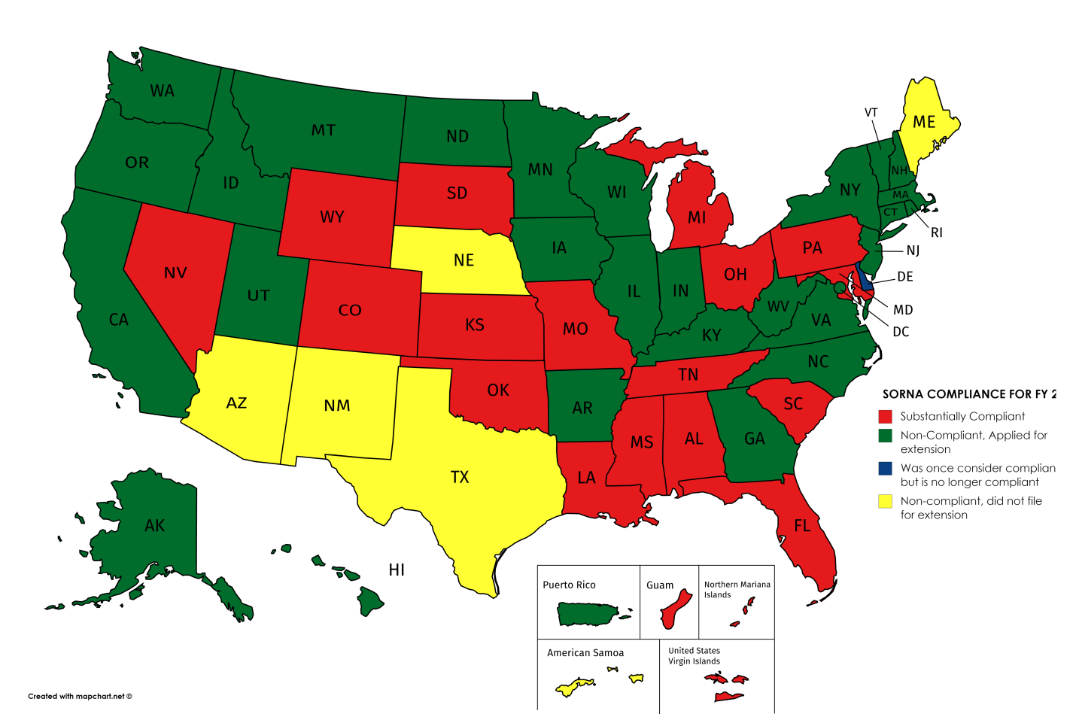
Derek W. Logue of OnceFallen.com
June 2016

How much money states REALLY lose by failing to adopt the AWA
A question was recently posed to me about the amount of BJS funding states really lose when failing to adopt the controversial Adam Walsh Act. This white paper is intended to analyze just how much states are losing by not adopting the AWA.
PART 1: DETERMINING TOAL JAG FUNDING
First, you must understand how much money is at stake here. First, we must understand how much money is REALLY at stake. First, we must get an idea just how much money is being given to the Byrne Memorial Justice Assistance Grant (JAG) program. According to the Office of Justice Programs, a total of $383.5 Million ($7.5 million more than in 2016) was requested for FY 2017. The OJP gives a breakdown of the JAG for the fiscal year of 2016 (FY 2014) by comparison:
- A total of $274.9 Million was allocated for JAG, and of this total,
- $181.8 Million in formula grants were allocated for states and territories (56 jurisdictions),
- $90.5 Million in formula grants were allocated to local government and Indian Tribes, and
- $6.7 Million to US Territories & DC.
- Of note is that the rest of the remaining funds are used for administrative and other purposes, including protection for presidential candidates.
Because FY 2016’s rates are similar to the amount requested for FY 2017, it is reasonable to assume the rates states receive for both fiscal years will be similar for purposes of determining how much money is being lost by not adopting the AWA.
PART 2: FINDING OUT HOW MUCH YOUR STATE RECEIVED IN JAG FUNDING
Four factors determine award amount for each state/ territory:
- Initial allocation based upon each jurisdiction’s share of violent crime and population;
- A minimum reward is established; states below the minimum threshold get the minimum amount (For FY 2016, that was $687,266), and states above the threshold receive the minimum plus an award based upon its share of total violent crime and population.
- The amount is split 60/40, with 60% going to the state and 40% going to local government. This step does not apply to US territories, which are federal jurisdiction.
- This last part is rather complex: Determining local award allocations, which are based on a jurisdiction’s proportion of the state’s 3-year violent crime average. If a local jurisdiction’s calculated award is less than $10,000, the funds are returned to the state to distribute. If the calculated local award is $10,000 or more, then the local government is eligible to apply for an award. This is important because this also factors into the penalty.
Below is the summary of every state’s JAG funding for FY 2016.
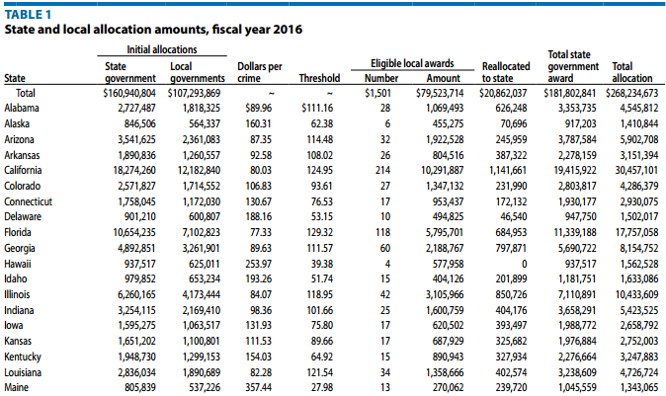
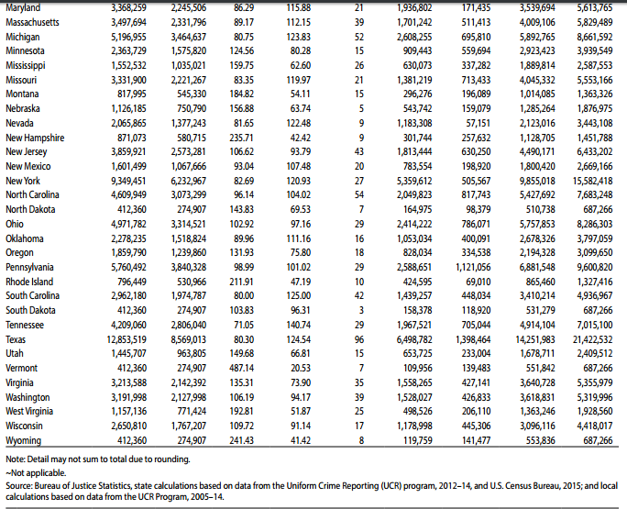
PART 3: UNDERSTANDING HOW MUCH STATES ARE REALLY PENALIZED FOR NOT ADOPTING THE AWA (AND HOW MOST AVOID IT WITHOUT ADOPTING AWA)
We’ve always been told that states failing to adopt the AWA would lose 10% of JAG funding. That is not necessarily true. Actually, states only lose a tenth of about 60% or so of JAG funding. Below is a very detailed (and rather lengthy) explanation of how the JAG cuts are calculated.
Question: Will the 10 percent penalty for failure to substantially implement the Sex Offender Registration and Notification Act (SORNA) apply to current Fiscal Year (FY) JAG funding?
Answer: Yes, the SORNA penalty will be applied to current FY JAG funding for non-compliant States/Territories.
The Adam Walsh Child Protection and Safety Act of 2006 (AWA) established a penalty for jurisdictions that failed to substantially implement the Sex Offender Registration and Notification Act (SORNA) by July 27, 2011, and for any year thereafter. See 42 U.S.C. § 16925(a).The Attorney General has delegated the task of determining when a jurisdiction has substantially implemented SORNA’s requirements to the Office of Sex Offender Sentencing, Monitoring, Apprehending, Registering, and Tracking (SMART Office).
For those jurisdictions that did not substantially implement SORNA by the annual deadline set by the SMART Office, the SORNA penalty will be calculated by subtracting 10 percent from the state government’s allocation (60 percent of the total award), after deduction of the “mandatory variable passthrough” that states are required to send to local governments. The penalty does apply to the portion of JAG funding that is awarded to the state to be shared with local governments that were not eligible for a direct JAG award (“less than $10,000 jurisdictions”) because the states retain control over these funds and may award the funds to another state agency (i.e., state police) in lieu of awarding them to a local government in localities where the state provides direct services to these localities.
The penalty is not assessed against the mandatory pass-through, which is the portion of JAG funds awarded directly to local law enforcement, as the state cannot retain any portion of that award. Penalizing local agencies would also seriously undermine the purpose of the statute, since doing so would be detrimental to local law enforcement efforts, which include the investigation, prosecution, and apprehension of sex offenders.
Below is an illustration of how the SORNA penalty is assessed:
If State X is to receive an initial state allocation of $3,000,000, the 10 percent SORNA penalty would be calculated as follows:
1. The mandatory pass-through amount of $1,200,000 (based on State X’s mandatory 40-percent pass-through) is subtracted from the $3,000,000; resulting in $1,800,000.
2. The “less than $10,000” allocation for State X, $250,000, is then added to the $1,800,000; resulting in $2,050,000.
3. The 10 percent SORNA penalty is then assessed on the $2,050,000 amount ($2,050,000 x .10); resulting in a SORNA penalty of $205,000 for State X.
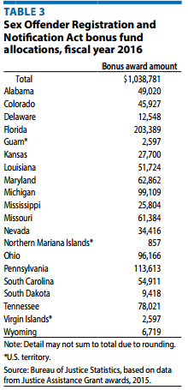
For the District of Columbia and the territories, the penalty will be assessed on the full allocation because the entire allocation goes to the District or territorial government…
It is important to note that states that failed to implement AWA can continue to collect the money they would otherwise forfeit if they use the funds towards SORNA compliance. The forfeited funds are given as bonuses to the AWA states.
Question: My state has substantially implemented SORNA. Are we eligible for additional JAG funding based on that compliance status?
Answer: Yes, SORNA compliant states/territories will have bonus funds applied to their next Fiscal Year (FY)JAG application. This bonus allocation is calculated based on SORNA penalty funds from non- implementing states and territories during that current FY. For example, if State X substantially implemented SORNA in FY 2014, State X would have an additional bonus funds added to their FY 2015 State JAG award, which will be comprised of SORNA penalty funds from non-implementing states and territories in FY 2014. The amounts available for compliant bonus funds will vary from year to year, depending on the amount of SORNA penalty funds that are assessed.
“In FY 2016, a total of 36 states and U.S. territories were not compliant with SORNA’s requirements. As a result, these jurisdictions received a combined $6,168,218 reduction to their FY 2016 Byrne JAG award. These jurisdictions were allowed to apply to reallocate the 10% penalty to promote SORNA implementation. Six states were SORNA noncompliant and did not apply to reallocate the penalty. Per the SORNA legislation, the $1,003,487 withheld from these jurisdictions will be reallocated to jurisdictions that did substantially implement SORNA [(42 USC § 16925(c)]. These funds will be reallocated to compliant states as part of the FY 2017 JAG award.”
Since only six states/territories both failed to adopt AWA and failed to file to receive the 10% funding for implementing AWA, these six states lot 10% of the state’s share of JAG funding. This bonus comes from the penalty assessed from the previous year’s penalty collection. “For FY 2016, a total of $1,038,782 was available from the FY 2015 SORNA reductions from the noncompliant states.” (See table.)
Florida received the largest bonus at $203,389. Of course, if the 6 holdout states work towards substantial compliance, then the bonus funds would be zero.
According to the SMART Office, the following jurisdictions applied for reallocation of the funding penalty in 2016 to work solely toward furthering SORNA implementation activities and efforts: Alaska, Arkansas, California, Connecticut, District of Columbia, Georgia, Hawaii, Idaho, Illinois, Indiana, Iowa, Kentucky, Massachusetts, Minnesota, Montana, New Hampshire, New Jersey, New York, North Carolina, North Dakota, Oklahoma, Oregon, Puerto Rico, Rhode Island, Utah, Vermont, Virginia, Washington, West Virginia and Wisconsin.Seventeen states are currently AWA compliant, leaving only 4 states—Arizona, Maine, Nebraska and Texas as the four states not applying to collect the 10% return on the JAG funds for FY 2017. Also worthy of note, Delaware was reported to be AWA compliant, and now Oklahoma is listed under compliant while Delaware is not.
PART #4: UNDERSTAND THE JAG FUNDS DO NOT TYPICALLY GO TO SORNA/REGISTRY
Each state collects the funds for various purposes, many of which aren’t related to SORNA. The Bureau of Justice Statistics website gives some indication of how JAG funds are allocated. The local grants for Florida, for example, included programs for reentry courts, rape prevention programs, SWAT gear, gang suppression, Rapid ID and printers, in-car video and technology upgrades, bodycams, and police vehicles. The state is less inclined to micromanage use of JAG funds, and it is possible some are used on registry issues. However, no funds from JAG are directly tied to the registry, save the 10% penalty on the 60% of JAG funds allocated to the states plus the state collection for rural jurisdictions.
PART #5: UNDERSTANDING THE SMART OFFICE GRANT PROGRAM
The AWA currently grants $20 million annually to the “SMART Office,” the bureaucracy responsible for promoting the AWA. However, of that $20 million, only about $9.8 million will “will be used to develop or enhance sex offender registration programs; improve law enforcement and other justice agency information sharing as it relates to sex offender registration and notification; and implement other efforts that further the objectives” of SORNA. This is done through direct grants. Of that money, jurisdictions can receive up to $400,000 towards SORNA implementation, while Indian Tribes can receive grants of up to $1 million.
For FY 2015, 43 jurisdictions won awards from a grant pot of $11.3 million, for an average of $267,441.86. In 2016, only 41 jurisdictions (16 states, 21 Indian tribes) competed for $9,841,532, for an average award of $240,037.
COST OF ADOPTING AWA
The Adam Walsh Act has proven very expensive to implement. Tina Walker, chief of media relations for California’s Emergency Management Agency, said compliance could exceed $30 million and would result in “a less than robust sex offender registration process for the state.” California would lose an estimated $3.2 million in JAG funding.
The 2010 Texas Senate Criminal Justice Committee Interim Report found that the cost of implementing the AWA provisions was $38,771,924, while the penalty for losing 10% of JAG/ Byrne Grant funding for the same period is merely $1,404,571. (For those who don’t like doing the math, the cost to implement is 27 times the cost of the penalty.) Texas would save money by not implementing the AWA even if the federal government took away 100% of JAG/ Byrne funding.
“The major cost of the AWA is the result of modifying registration requirements. The most significant change to Texas would be the required registration of offenders with offenses that are not currently included in the list of offense requiring register. An example of this is kidnapping of a child. Currently an individual only has to register if there is an element of sexual intent or if an assessment is done that indicates the individual is a risk for sexual misconduct. AWA does not call for the utilization of risk assessments and relies solely on offense. This would cause the number of people on the registry to increase greatly. The AWA also increases the number of time an offender has to verify their information with law enforcement. The number of times is determined by the tier they are in. There are three tiers; three is the most severe. Another major change is that sex offenders not only have to submit fingerprints and information but also DNA to law enforcement. The length of required registration is also modified by AWA. Tier one people would have to register for fifteen year; tier two for twenty five years; tier three for life.”
In 2009, Florida stated they “may lose $2,167,000 (House bill) or $2,852,000 (Senate bill) in JAG funding based on the application of the 10 percent JAG funding reduction penalty to the projected FY09 JAG allocation to Florida, if information received by FDLE staff from SMART office staff is correct that the 10 percent JAG funding reduction penalty only affects the JAG block award (60% of Florida’s total JAG allocation) and the local direct awards of less than $10,000 (a portion of the remaining 40% of Florida’s total JAG allocation). The estimated fiscal impact for FY09-10 on FDLE, the Department of Corrections (DOC), and the Department of Juvenile Justice (DJJ) of implementing SORNA requirements based on prior and proposed implementation legislation would be approximately $3,226,487.18 Therefore, if Florida fully implemented SORNA in FY09, the projected impact on these agencies would be greater than the amount Florida would receive from full JAG funding (as projected by FDLE).

However, it is worth noting that Florida projection was only on the state level:
“The total fiscal impact of SORNA compliance cannot be measured solely on the basis of projected costs on state agencies, as there is likely to be a fiscal impact on local law enforcement agencies and others22 in complying with SORNA. However, these impacts cannot be calculated. Only one sheriff‟s office,23 the Putnam County Sheriff‟s office, was willing to speculate what that fiscal impact might be: one new detective position at a cost of approximately $55,000 to $60,000. It appears that sheriffs may not be able to categorize actual costs because responsibilities relating to the sex offender registration process may be shared by several people. Further, these people may have other responsibilities in addition to registration responsibilities.”
In 2008, Virginia determined that the first year of compliance with the registry aspect of SORNA would cost more than $12 million. The first year of implementing SORNA would cost the Commonwealth of Virginia $12,497,000. The yearly annual cost of SORNA would be $8,887,000. Adjusted with a 3.5 percent yearly inflation rate, Virginia would be paying more than $10 million by 2014. If Virginia chose to comply with SORNA, the state would spend $12,097,000 more than it would if it chose not to implement SORNA and forfeit 10 percent of its yearly Byrne grant, a loss totaling approximately $400,000.
Ohio determined that the cost of implementing new software to create a registry would approach a half million dollars in the first year. The total estimated cost for complying with SORNA exceeds the Byrne funds Ohio would lose if it did not comply. Installing and implementing software alone would cost $475,000 in the first year. The software would then cost $85,000 annually thereafter for maintenance. Certification of treatment programs based on new standards and providing a description of a person on the registry to the state’s Bureau of Criminal Identification and Investigation would cost another $100,000 annually. Ohio also lists other factors that would increase the cost of implementing SORNA, including salaries and benefits for new personnel, new court and administration costs, and costs to counties and municipalities. These costs are in addition to the $475,000 needed for software, but have not yet been quantified by the state. If Ohio chose not to implement SORNA, the state would lose approximately $622,000 annually from its Byrne funds. However, the total estimated cost of software, certification of treatment programs, salaries, and benefits for new personnel would exceed the lost Byrne funds.
In 2010, Ohio spent $379,622 just for the maintenance of the public registry. Statewide, Ohio’s registry flipped after implementing SB 10 (Ohio’s AWA law). Reclassification came at a cost; under Ohio’s old registration scheme, 77% of Ohio registrants were classified as “sexually oriented offenders” (i.e., Tier I), 4% were labeled “habitual sexual offenders” (Tier II), and 18% were labeled “sexual predators” (Tier III). Under SB 10, only 13% of offenders were reclassified into Tier I, 33% were in Tier II, and 54% were in Tier III. This led to numerous lawsuits; Ohio also spent more than $10 million in lawsuits over reclassification under the AWA.
Hamilton County, Ohio (Cincinnati Metro area) also provides valuable insight into the cost of the Adam Walsh Act at the local level. “At the local level, the Hamilton County’s Sheriff’s Department finds this re-classification has increased the sexual predator group (the new Tier III) from 400 in late 2007 to about 1,100 predators with the enactment of Senate Bill 10 on January 1, 2008. Costs for postage for required mailed notifications are expected to rise from $250,000 in 2007 to $500,000 in 2008 if everyone within 1,000 feet of a predator is notified every 90 days. This projected cost does not include increased expenses of printing and staff for increased community notification. Currently the Sheriff’s Office has four employees who dedicate much of their time to sex offender registration and notification.”
Local 12 Cincinnati reported an increase of labor for the local registry office. “It means more paperwork, more computer work. ‘It's tripled. The workload for us has tripled.’ And because of all that... Deputy Adam Breeze, Hamilton County Sheriff's Office: ‘No free time to do anything else. If we need to look at some files, or write a warrant, or investigate some offenders, it really cracks down on our time, in that aspect, with the tripling of our registration with offenders…’ In Hamilton County alone, 600 low level offenders are now high level offenders... same people, no new crime, just a new label.” The Buckeye State Sheriffs’ Association estimated that the new law had increased sheriffs’ workloads by 60 percent.
PUTTING ALL OF THIS INTO SIMPLE TERMS (KIND OF)
This was a lot of boring and confusing reading, but hopefully we can get some idea of how much money states stand to lose for failing to implement the AWA. So, here is a summary of the rewards and penalties.
- Each state/territory gets a cut of the JAG funds depending on population and amount of crime. Obviously, bigger states get a bigger share. These funds are used for various law enforcement purposes, not just sex offender registries.
- JAG for each state is split 60/40, with 60% going to states and 40% to municipalities. In addition, awards of under $10,000 to municipalities are handled by the State.
- The penalty of non-compliance with SORNA is 10% of the portion that goes to the state (60% plus the “less than $10,000” allocations).
- States can avoid losing the 10% of funds so long as they agree to use that 10% they would have lost to work towards SORNA compliance. For FY 2017, only 4 states (Arizona, Maine, Nebraska and Texas) and one US Territory (American Samoa) failed to submit a request for collecting the lost funding. The status of Delaware is uncertain at this time.
- SORNA complaint states received a bonus collected from the forfeited funds from the states that rejected SORNA compliance. For FY 2016, that amount total just over $1 million.
- The SMART Office also gives out grants of up to $400,000.
The short answer is that states get the supposed “benefit” of keeping the funds they were once awarded they stood to lose for failing to become substantially compliant with SORNA, plus a small bonus collected from non-AWA states that fail to apply to use the funds towards SORNA compliance. This alleged benefit is minimal at best. The privilege of keeping the penalty money cannot be truly considered a benefit; it was money once guaranteed but held for virtual ransom by the federal government and that penalty money can only be used to work towards SORNA compliance.
So if a SORNA compliant state like Florida decided to rescind substantial compliance with SORNA in FY 2016, they would have lost 10% of the $11,339,188 total award to the state ($10,654,235 directly to the state plus $684,953 “less than $10,000” local allocation), meaning Florida loses $1,133,918 in JAG funds. Florida would have also lost that $203,389 in bonus funds from the penalty money pool from the states that opted out of SORNA compliance. The total of lost funds for Florida for FY 2016 in this hypothetical scenario would have been $1,317,007.
Projecting the total cost of implementing SORNA is difficult. Based on the numerous reports available, the state level costs include the cost of changing the laws itself, updating and maintaining the state’s public registry, and new training for law enforcement on the new laws. The costs are more likely to be found on the local level, where information on costs will be scarce. Below are some identified costs at the local level:
- Increased dedicated personnel for registry offices and compliance checks;
- Increase of notification costs (postage, fuel, overtime depending on notification technique);
- A larger number of registrants staying on the registry for life means an ever-growing registrant population must be monitored for longer and more frequently;
- Increased workload for law enforcement personnel.
This important, especially considering JAG funding for states has reduced from $457 million in FY 2010 to $255 in FY 2015, with the number remaining constant in FY 2016 and FY 2017.
In short, the cost of SORNA compliance far exceeds the penalty for failure to comply or any claim of “benefit” for adopting this controversial law. The biggest expense is found at the local level, where data is not often released. More research must be done to assess cost at the state level and local level, but the evidence presented in this guide shows there is no real benefit but plenty of cost associated with SORNA compliance.
--Derek W. Logue of OnceFallen.com

“OFFICE OF JUSTICE PROGRAMS, Program Name: Byrne Justice Assistance Grant (JAG) Program.” Web. <https://ojp.gov/about/pdfs/BJA_Byrne%20Justice%20Assistance%20Grants%20(JAG)%20Program%20Summary_For%20FY%2017%20PresBud.pdf>
Technical Report: Justice Assistance Grant Program, 2016.” US Dept. of Justice. Sept. 2016. Web. <https://www.bjs.gov/content/pub/pdf/jagp16.pdf>
Ibid., p.2
“Edward Byrne Memorial Justice Assistance Grant (JAG) Program: Frequently Asked Questions (FAQs) – Updated June 2017.” BJS. June 2016. Web. <https://www.bja.gov/Funding/JAGFAQ.pdf>
Ibid.
JAG 2016, p.7
Ibid.
See https://smart.gov/newsroom.htm
See https://smart.gov/newsroom_jurisdictions_sorna.htm
See https://bjafactsheets.iir.com/
“Florida: BJA FY 2014 investments.” BJA. Web. <https://bjafactsheets.iir.com/PDF/BJA_Investments-FL.pdf>
“JUSTICE DEPARTMENT ANNOUNCES ALMOST $18 MILLION IN AWARDS TO SUPPORT SEX OFFENDER REGISTRATION, ASSESSMENT, INTERVENTION.” OJP. 29 Sept. 2016. Web. Press Release. <https://ojp.gov/newsroom/pressreleases/2016/ojp09292016_2.pdf>
https://smart.gov/funding.htm
See https://ojp.gov/about/pdfs/Adam%20Walsh%20Act%20(SMART%20Office)%20program%20summary_For%20FY%2017%20PresBud.pdf
See https://external.ojp.usdoj.gov/selector/title?solicitationTitle=Support%20for%20Adam%20Walsh%20Act%20Implementation%20Grant%20Program&po=SMART
“Some States Refuse to Implement SORNA, Lose Federal Grants.” Prison Legal News. 19 Sep. 2014. Web. <https://www.prisonlegalnews.org/news/2014/sep/19/some-states-refuse-implement-sorna-lose-federal-grants/>
Texas Senate Committee on Criminal Justice Interim Report. 15 Dec. 2010. Web. <http://www.senate.state.tx.us/75r/senate/commit/c590/c590.InterimReport81.pdf>
See http://archive.flsenate.gov/data/Publications/2009/Senate/reports/interim_reports/pdf/2009-312cj.pdf, p.3-4
Ibid., p.4
“What will it cost states What will it cost statesto comply with the Sex to comply with the Sex Offender Registration and Notification Act? Justice Policy Institute. 2088. Web. <http://www.justicepolicy.org/images/upload/08-08_fac_sornacosts_jj.pdf>
Ibid.
See http://docslide.net/documents/oh-offender-watch-contract.html
Amy Borror Written Testimony. HEARING ON THE SEX OFFENDER REGISTRATION AND NOTIFICATION ACT (SORNA). U.S. HOUSE OF REPRESENTATIVES, COMMITTEE ON THE JUDICIARY, SUBCOMMITTEE ON CRIME, TERRORISM, AND HOMELAND SECURITY. 9 March 2009. Web. <https://judiciary.house.gov/_files/hearings/pdf/Borror090310.pdf>
“Complying with Walsh Act costs Ohio $10 million.” The Vindicator. Vindy.com. 13 Nov. 2011. Web. <http://www.vindy.com/news/2011/nov/13/complying-with-walsh-act-costs-ohio--mil/?print>
“Sex Offenders and Communities, Special Report No. 3-10.” Hamilton County Regional Planning Commission. Feb. 2008. Web. < https://ccoso. org/sites/default/files/import/SexOffendersInCommunitiesSpecialReport.pdf>
Hirsh, Jeff. “High Cost of New Sex Offender Law. Local 12. 12 Feb 2008. Web.
“Ohio's tougher sex offender law being met with lawsuits, confusion.” Cleveland Plain Dealer. 21 Jan 2008. Newspaper.

